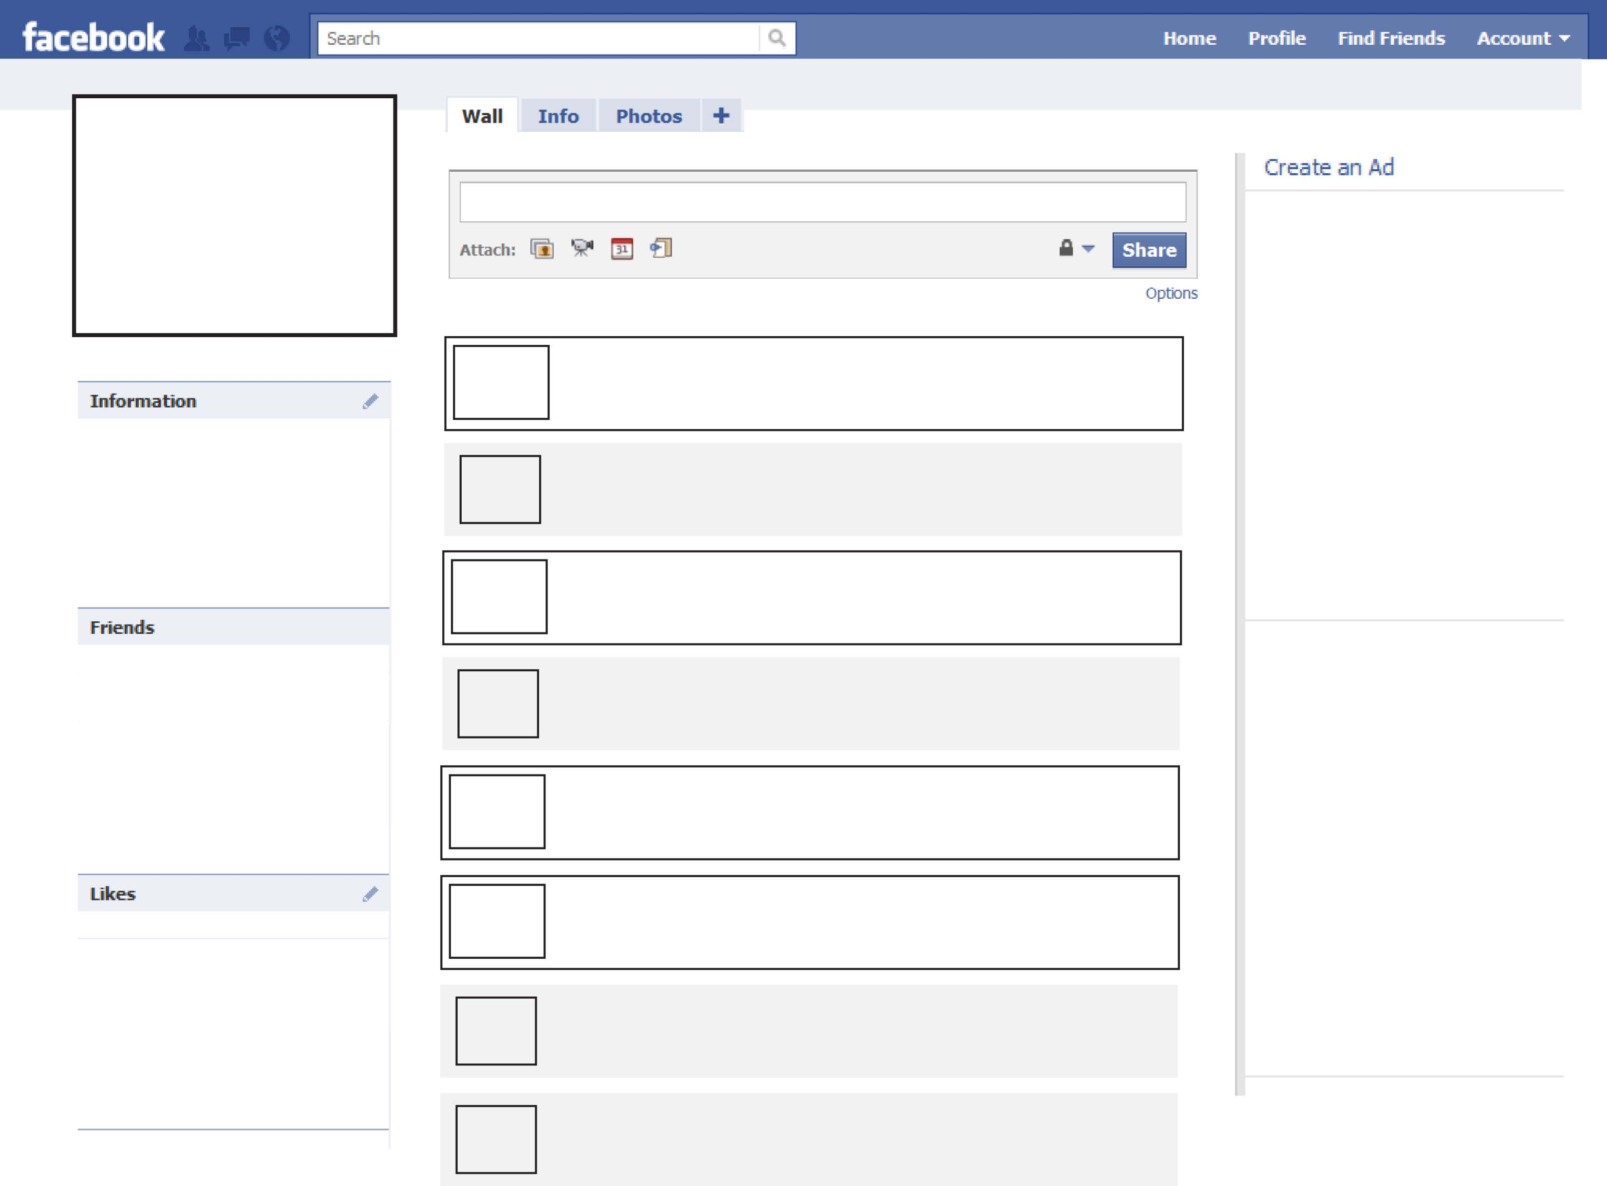

Place possible likes here.

Place likely friend’s pictures here.

Put biographical information here.

Create an Ad and place it here

Create an Ad and place it here

Type wall post here.

Type wall post here.

Type wall post here.

Type wall post here.

Type wall post here.

Type wall post here.

Type wall post here.

Type wall post here.